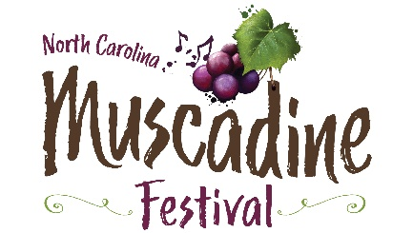

Craft or Commercial Vendor Application
2024 North Carolina Muscadine Festival
Saturday, September 28th, 2024
10am-6pm
Duplin County Events Center Grounds, Kenansville, North Carolina
(Vendors will not be allowed to have a moving vehicle in the festival area until after closing)

Featuring: The Main Event, The Embers & The Tams
North Carolina wineries!!

- Spaces are limited and are on a first-come basis.
- Application deadline is August 30, 2024.
- Food vendor applicants should use the “Food Vendor” form, not this one.
- NC Muscadine Harvest Festival reserves the right to approve all vendors.

Vendor Name: _____________________________________________________
Address: __________________________________________________________
City, State, Zip: ____________________________________________________
Phone #: ______________________ Email Address: ______________________
Items for sale or raffle
___________________________________________________________________
Number of 10’ x 10’ booths required __________ x $150 ea. $____________
Number of 120 volt/20 amp circuits needed _____ x $20 ea. = $_____________
Additional vendor wristbands (up to two) x $10 each (2 provided) $ _____
Total enclosed $_____________

Please make checks payable to: NC Muscadine Festival, 195 Fairgrounds Dr, Kenansville, NC 28349. (Checks must be included with application form to be considered. If application is not accepted, check will be returned).

For questions, call, or email Christa Parker at 910-296-2181,
muscadinefestival@gmail.com

