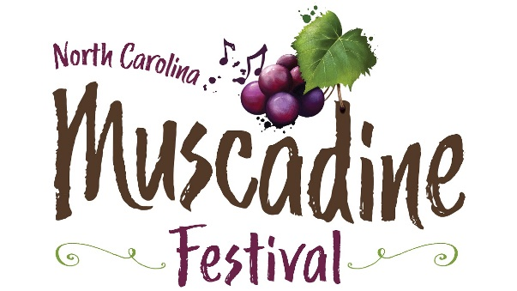

Please join us for the 20th annual
North Carolina Muscadine Festival
Saturday, September 28, 2024 – 10 a.m. – 6 p.m.

www.ncmuscadinefestival.com

Featured bands: The Main Event, The Embers and The Tams

Winery Invitation

We invite you to attend the 2024 North Carolina Muscadine Festival and join us for a great time. You will have the option to park your vehicles behind your tent just like last year, and we will provide free ice as well. You will receive a tented space of 20x20 along with tables and chairs. There is no registration fee, but you must reserve your spot so that we can include you in our advertising and promotion. Also, please make sure to provide us with a copy of your Certificate of Insurance. Please note that we have a limit of 25 wineries.
Two-vehicle parking passes will be provided. These will allow your vehicle(s) to enter through the vendor parking lot. We will also provide up to four vendor wristbands for your workers. These will allow entry/re-entry at the main gate. Please indicate how many wristbands you need below.
***All wineries are required to donate six bottles of wine to be used for event promotions**
**Wine must be dropped off at the time of check-in**
**Please let the Muscadine Festival staff know if you need a tent by July 14th**

Winery Name: _______________________________________________

Mailing Address: ______________________________________________

Email: _______________________________________________________

Contact Name: ___________________ Phone: ______________________

Number of vendor wristbands needed for workers (up to four): ________

Please Return no later than July 14th. Space reservations are accepted a
first-come, first-served basis.

Return to: Duplin County Events Center, Kenansville, North Carolina 28349
Contact: Christa Parker, 910-296-2181
email: muscadinefestival@gmail.com

